

**The A Team**

**Image Processing Tool for**

**Leidenfrost-Ratchet Systems**

**Design Document for Version 2.0 (First Draft)**

March 27, 2014

**Authored By:**

Sanan Aamir

Romando Garcia

Anne Lam

James Rowe

Hieu Tran

Table of Contents

1. Introduction 2
   1. Purpose of Design Document 2
   2. Project Scope and Objectives 2
   3. Document Organization 2
   4. Audience 2
2. Design Overview 3
   1. Approach 3
   2. Optimization Goals 3
   3. Design Patterns 3
3. User Interface Diagram 3,Appendix A
4. System Architecture 4
5. UML Diagram 4
   1. Sequence Diagram 4, Appendix B
   2. UML Class Diagram 4, Appendix C
   3. Use Case Diagram 5
6. Glossary 6
7. References 6

**1. Introduction/Overview**

The design document details the project design for the design phase of the development process.

1.1 Purpose of Design Document

The design document will overview the intended user interface, UML diagrams, and the system architecture.

1.2 Project Scope and Objectives

The scope comprises what we intend to implement and nothing more. The software's current capacity is to efficiently track a drop of liquid and record measurements through images gathered from a high speed camera as it falls from an injection needle and travels along a ratchet surface. We intend to add to this by implementing the following new design plan.

1.3 Document Organization

This document is organized into the following sections:

|  |  |
| --- | --- |
| Introduction | Provides information related to this document |
| Design Overview | Describes the approach, optimization goals, and design patterns |
| System Architecture | Describes the various components and the integration between them. |
| UML Diagram | Describes the overall design of sequence, class, and use case diagram |
| Glossary | Explains the definition and terminology |
| Reference | Lists all of the material used in producing this document |

1.4 Audience

The intended audience of this document is the development team and testers.

**2. Design Overview**

The design overview describes the process of the design phase.

2.1 Approach

After the initial design of the user interface, UML diagrams were created. All aspects of design were then organized within this document.

2.2 Optimization Goals

As low processing times are a necessity, multi-threading will be utilized to optimize the speed of the tool. The previous version of the Image Processing tool achieved low processing times on a single thread. Our goal is to improve on these times while maintaining a responsive interface at all times.

2.3 Design Patterns

The design will accommodate three major classes: Image Processing Form, which consists of the user interface and its controls, Droplet Image, which holds the object of the image and includes the algorithms and fine-tuning capability, and Output, which will export the data into Excel files.

**3. User Interface Diagram**

The user interface was designed to be user-friendly, simple, and intuitive via tool tips. The purpose of the user interface is to aid the user as much as possible for simple application use. The user will click on the Load button and upload a folder of images. Then the user will enter Frame Rate, Base/Needle Height, and Black/White Calibration. Finally, the user will click the Run button and the system will generate an Excel file. The Excel file will consist of volume, acceleration, and velocity. If the data seems incorrect, the system will alert the user and allow them to re-calibrate. Then the user will click the Run button again and it will generate a new Excel file. See Appendix A.

**4. System Architecture**

The purpose of this figure is to show the integration required between various components to use this Image Processing tool. In summary, a high speed camera captures images in sequence of a droplet released by an injection needle as it travels along a ratchet surface. The images are processed by the tool to calculate and then export data to a spreadsheet application.

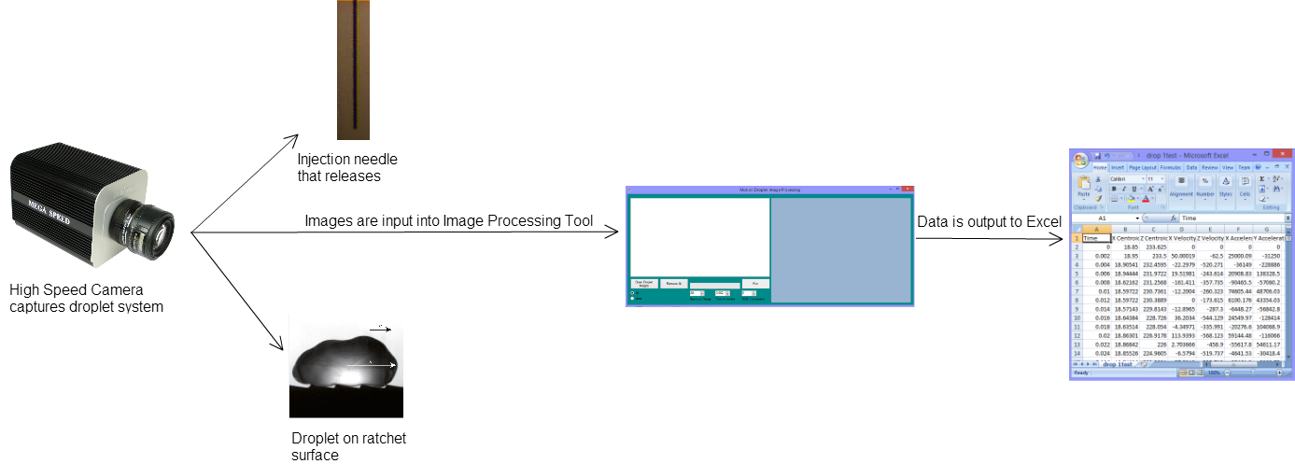

Figure 1. System architecture for the Image Processing tool.

**5. UML Diagrams**

The purpose of UML diagrams is to help the development team organize what processes need to be implemented and how implementation will occur.

5.1 Sequence Diagram

The purpose of the sequence diagram is to describe the sequence of actions the user may take in using the Image Processing tool. The sequence diagram specifically outlines the interaction between the user and the user interface in detail, accounting for individual class actions. See Appendix B.

5.2 Class Diagram

The class diagram lists the properties and methods for each of the major classes as we have decided so far. See Appendix C.

5.3 Use Case Diagram

The use case diagram purpose is to tell a story between the user and the software interface. The user will load the data, input the frame rate, input the width of the image, run the process, and fine-tune the location of the needle if needed. The output will then show the real time measurements in an Excel output file.

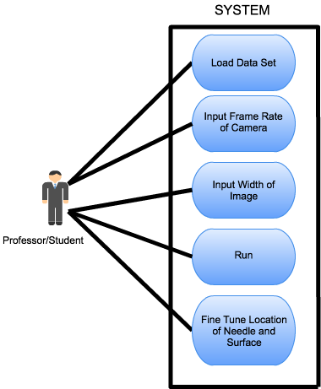

Figure 2. Use Case Diagram of the Image Processing Project

**6. Glossary**

|  |  |
| --- | --- |
| **Term** | **Definition** |
| **Leidenfrost-Ratchet System** | A system involving a ratchet surface heated to a fluid's Leidenfrost point will allow a droplet of that fluid to spontaneous accelerate along that surface, even if it means traveling up slope. |
| **UML** | Unified Model Language |
| **Droplet** | A very small drop of a liquid. |

**7. References**

This document was completed with the guidance from the Online Screening Tool Tech Design Document, Design Powerpoints written by Catherine Stringfellow, a professor at Midwestern State University, and the presentation of Julia John and James Miller on UML Diagrams for the Software Engineering class at Midwestern State University.

Appendix A - User Interface Prototype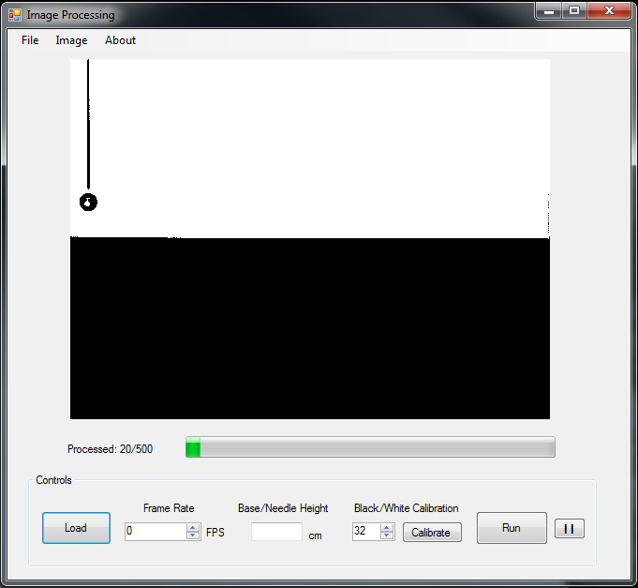

Appendix B - UML Sequence Diagram

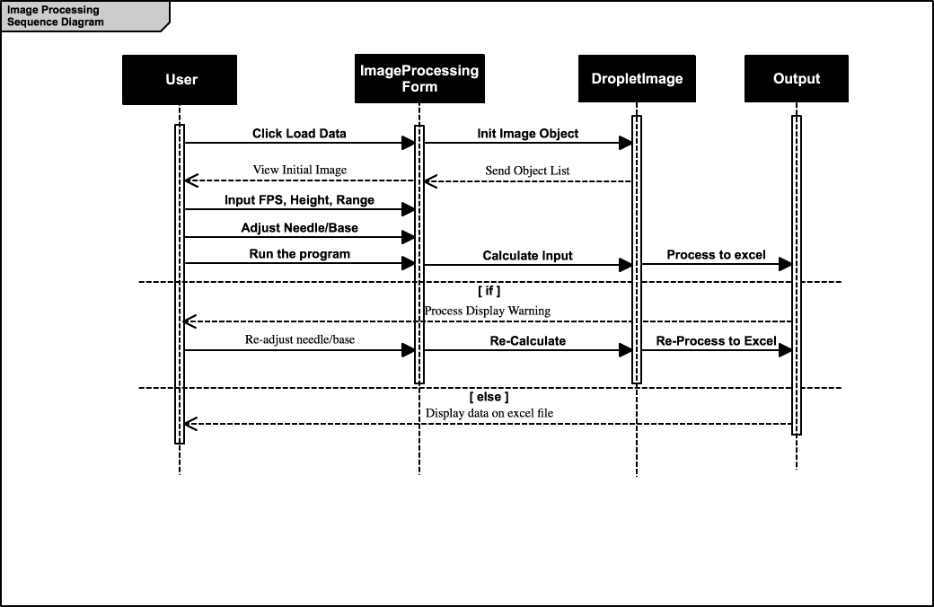

Appendix C - UML Class Diagram

